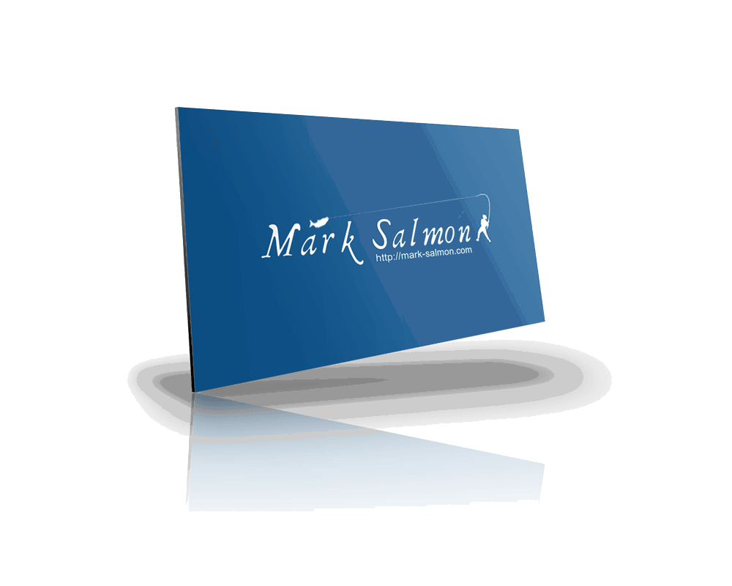Marketing audit
Insert client name here if you wish
Presented by: Mark Salmon

Marketing Audit

Ranking vs. competitors for keyword phrases:

No. of inbound links:

Is there a blog?

If so, how often are posts published?

Is the content compelling?

Does the content include Calls To Action?

Does the site and/or blog have keyword optimized content, page titles, descriptions, images and headers?

Are there social media sharing buttons/icons?

Is there an active, responsive social media presence?

If so, where (Facebook, Twitter etc)?

Is there a contact form on the site?

Can visitors subscribe or sign up to receive updates?

Is there an effective enticement offered to sign up?

Is the email list segmented?

Do follow up messages and broadcasts serve the overall business needs and strategy?

Questionnaires

Marketing Audit Questionnaire

Have you defined your ideal customer?
 | Yes, absolutely |  | Somewhat |  | No |  | I don’t know what this means

Does Your Business have an account on facebook?
 | Yes |  | No

Does Your business have a twitter account?
 | Yes |  | No

Does your business have accounts on other social media platforms? Tick all that apply:
 | Google+ |  | LinkedIn |  | YouTube |  | Pinterest

If you have other social media accounts for your business please list them here:

Is your business using social media to build brand awareness, increase engagement and drive traffic?

 | All of these |  | Some of these |  | No |  | Unsure

Do you have offers/giveaways on your site to entice visitors and subscribers?
 | Yes |  | No

If yes, please tick all that apply:

 | eBook |  | eCourse |  | Whitepaper |  | Video/Webinar

Is your business using social media to build brand awareness, increase engagement and drive traffic?

 | All of these |  | Some of these |  | No |  | Unsure

How many of your website visitors convert into leads?

How many of your website visitors convert into subscribers?

How many of your website leads convert into customers?

how many landing pages do you have on your site?

are these landing pages the same for every visitor or are they targeted and tailored to meet the visitors’ needs?
 |  | The same |  |  | Targeted |  |  |  | Unsure

how often do you send out email messages?

are these email messages segmented?

 | Yes |  | No |  | Unsure

Do you have website analytics in place?

 | Yes |  | No |  | Unsure

do you analyze your social media impact and interactions?

 | Yes |  | No |  | Unsure

Do you connect with your leads via social media?

 | Yes |  | No |  | Unsure

